**Sanika Kadam**

**2124UCSF112**

**1.Introduction**

To enhance the user experience, developers can implement a feature that redirects users to a map application when they click on a "View Location" button. This feature passes the destination address to the map application, allowing users to navigate to the location with ease.

**2. Tools & Technologies Used**

* Android Studio
* Java/Kotlin (Java)
* Emulator or Physical Device

**3. Procedure & Steps**

**Step 1: Create a New Project**

* Open Android Studio and create a new project.
* Select Bottom Navigation Views Activity
* Set the project name and package name.
* Select the programming language (Java).

Screenshot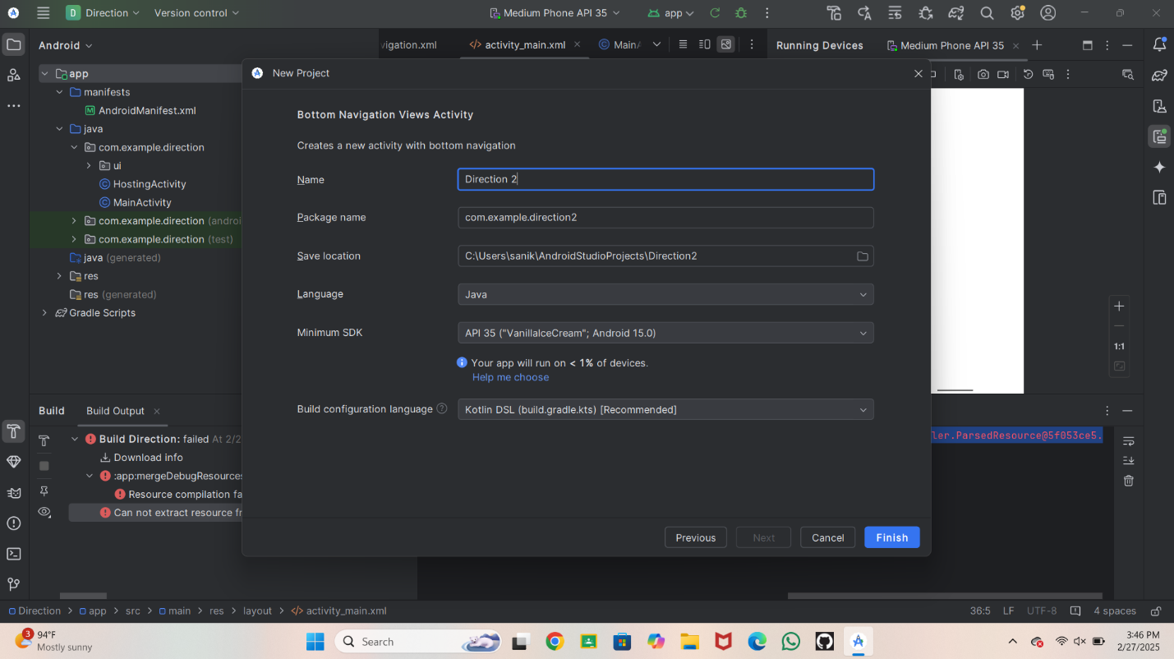 **Step 2: Designing the UI**

* Open activity_main.xml and design the layout using XML.
* On Left side go on a java then com.example floatingcontextmenu
* Then take main activity
* Write a code in main activity java
* ScreenShot

package com.example.direction2;

import android.content.ActivityNotFoundException;

import android.content.Intent;

import android.net.Uri;

import android.os.Bundle;

import android.widget.Button;

import android.widget.EditText;

import android.widget.Toast;

import androidx.appcompat.app.AppCompatActivity;

import com.example.direction2.R;

public class MainActivity extends AppCompatActivity {

private EditText etFromLocation;

private EditText etToLocation;

private Button btnGetDirection;

@Override

protected void onCreate(Bundle savedInstanceState) {

super.onCreate(savedInstanceState);

setContentView(R.layout.activity_main);

etFromLocation = findViewById(R.id.etFromLocation);

etToLocation = findViewById(R.id.etToLocation);

btnGetDirection = findViewById(R.id.btnGetDirection);

btnGetDirection.setOnClickListener(view -> {

String userLocation = etFromLocation.getText().toString();

String userDestination = etToLocation.getText().toString();

if (userLocation.equals("") || userDestination.equals("")) {

Toast.makeText(MainActivity.this, "Please enter your location & destination", Toast.LENGTH_SHORT).show();

} else {

getDirections(userLocation, userDestination);

}

});

}

private void getDirections(String from, String to) {

try {

Uri uri = Uri.parse("https://www.google.com/maps/dir/" + from + "/" + to);

Intent intent = new Intent(Intent.ACTION_VIEW, uri);

intent.setPackage("com.google.android.apps.maps");

intent.setFlags(Intent.FLAG_ACTIVITY_NEW_TASK);

startActivity(intent);

} catch (ActivityNotFoundException exception) {

Uri uri = Uri.parse("https://play.google.com/store/apps/details?id=com.google.android.apps.maps");

Intent intent = new Intent(Intent.ACTION_VIEW, uri);

intent.setFlags(Intent.FLAG_ACTIVITY_NEW_TASK);

startActivity(intent);

}

}

}

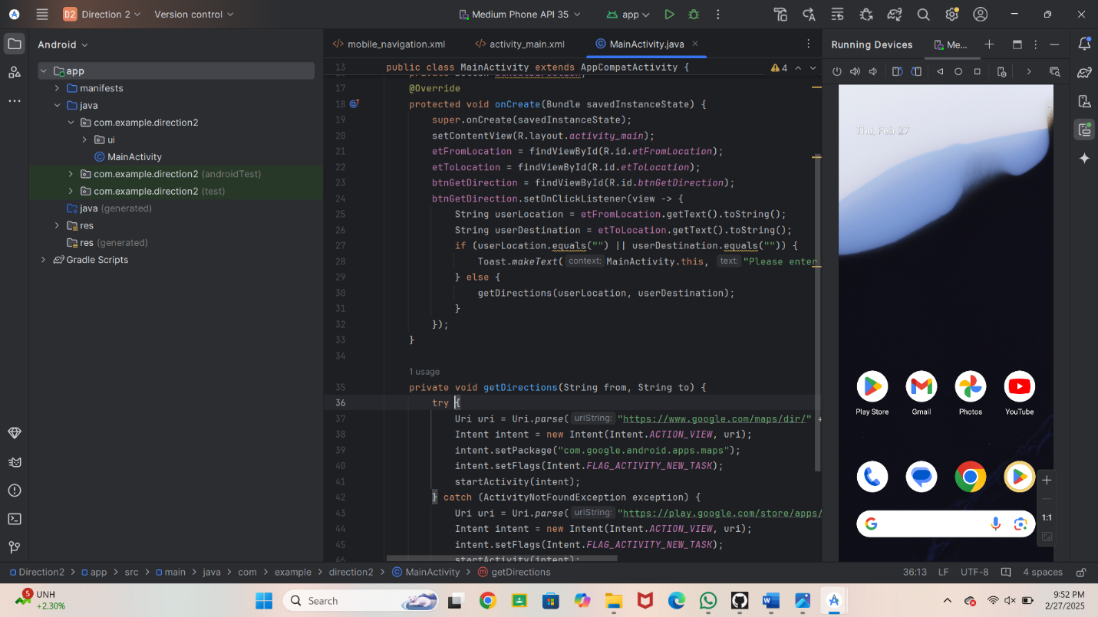

**Step 4:**

* Write a code in activity main xml

<?xml version="1.0" encoding="utf-8"?>

<androidx.constraintlayout.widget.ConstraintLayout xmlns:android="http://schemas.android.com/apk/res/android"

xmlns:app="http://schemas.android.com/apk/res-auto"

xmlns:tools="http://schemas.android.com/tools"

android:id="@+id/container"

android:layout_width="match_parent"

android:layout_height="match_parent"

android:background="#FFFFFF"

android:padding="16dp"

android:paddingTop="?attr/actionBarSize"

tools:context=".MainActivity">

<EditText

android:id="@+id/etFromLocation"

android:layout_width="0dp"

android:layout_height="wrap_content"

android:ems="10"

android:hint="Enter your location"

android:inputType="textPersonName"

app:layout_constraintBottom_toBottomOf="parent"

app:layout_constraintEnd_toEndOf="parent"

app:layout_constraintStart_toStartOf="parent"

app:layout_constraintTop_toTopOf="parent"

app:layout_constraintVertical_bias="0.38" />

<EditText

android:id="@+id/etToLocation"

android:layout_width="0dp"

android:layout_height="wrap_content"

android:layout_marginTop="32dp"

android:ems="10"

android:hint="Enter destination"

android:inputType="textPersonName"

app:layout_constraintEnd_toEndOf="@+id/etFromLocation"

app:layout_constraintStart_toStartOf="@+id/etFromLocation"

app:layout_constraintTop_toBottomOf="@+id/etFromLocation" />

<Button

android:id="@+id/btnGetDirection"

android:layout_width="wrap_content"

android:layout_height="wrap_content"

android:layout_marginTop="24dp"

android:text="Get Direction"

app:layout_constraintEnd_toEndOf="@+id/etToLocation"

app:layout_constraintStart_toStartOf="@+id/etToLocation"

app:layout_constraintTop_toBottomOf="@+id/etToLocation" />

</androidx.constraintlayout.widget.ConstraintLayout>

Screenshot

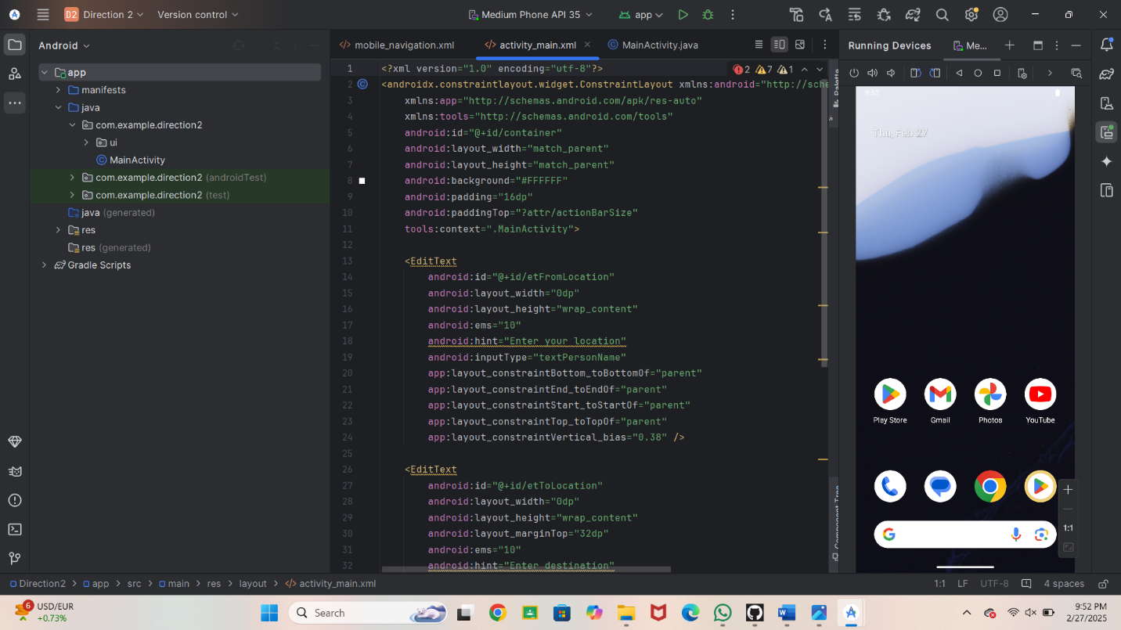 Ste

* **Step 5**: Run the emulator

Screenshot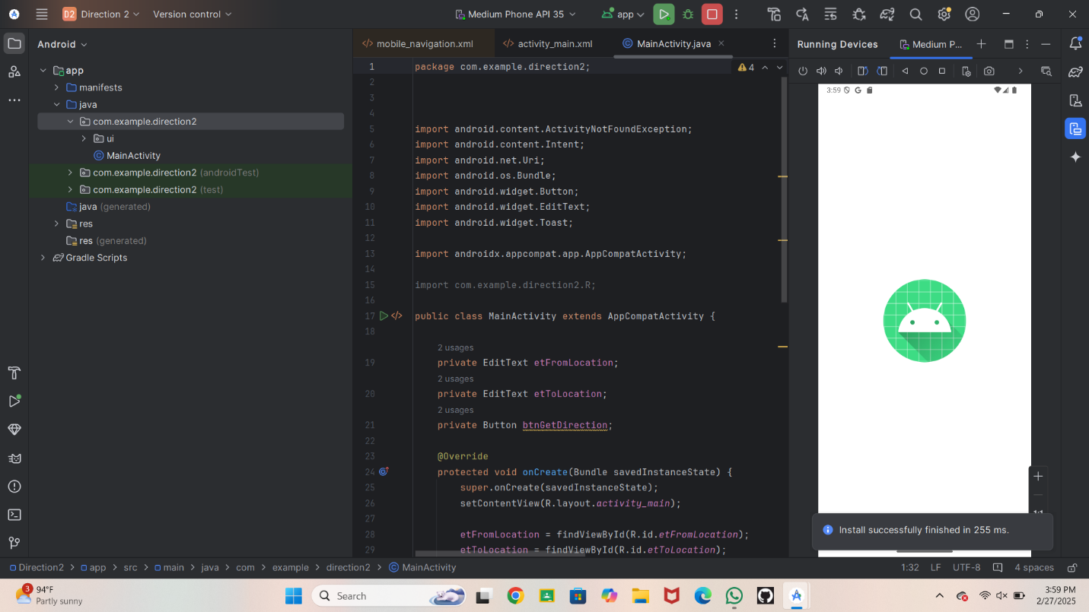 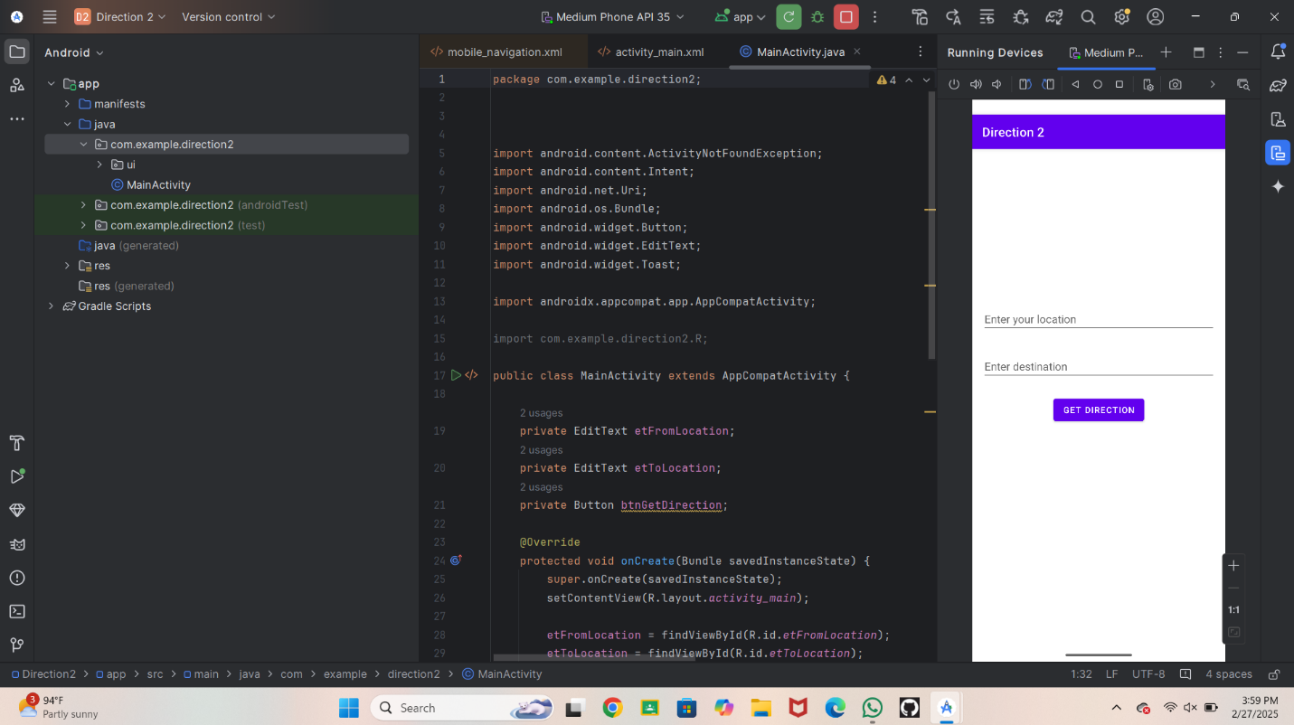**Step 6:**

* Write a Your Location
* Then write you Destination
* Then click on the button Get direction
* Screenshot

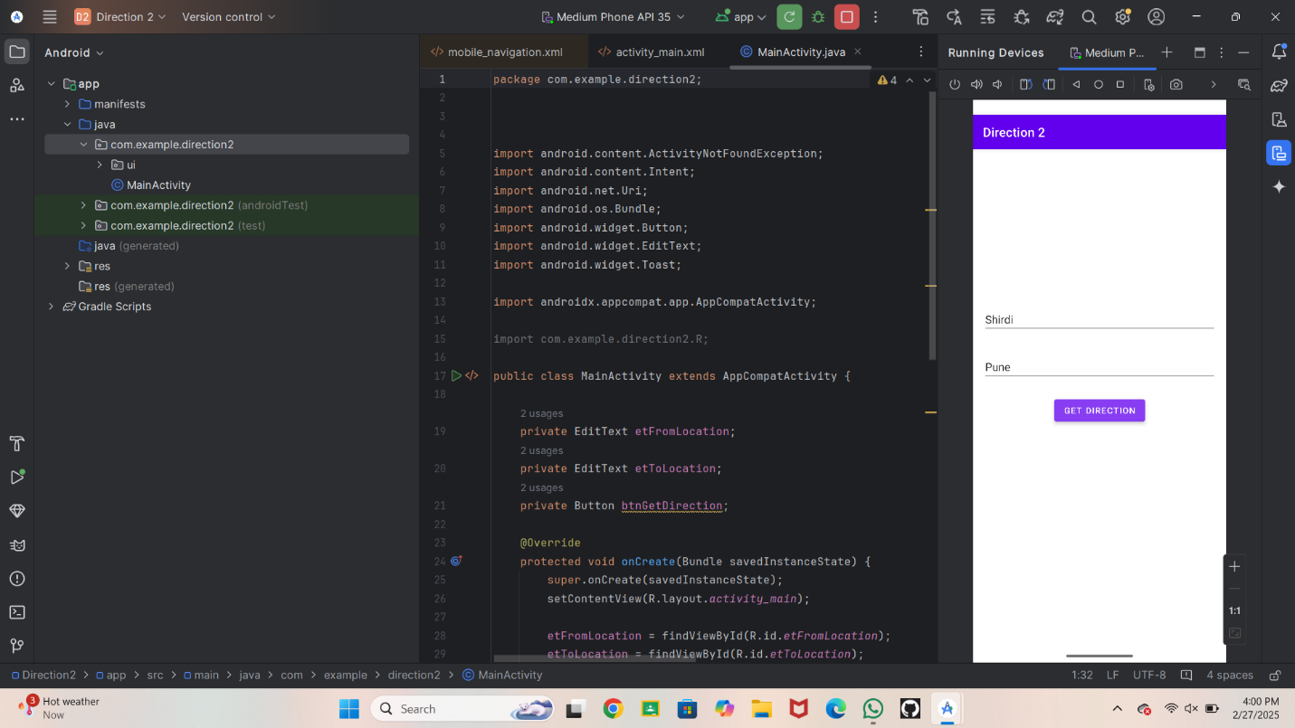

**Step 7:**

* After clicking On the get direction button we get the map 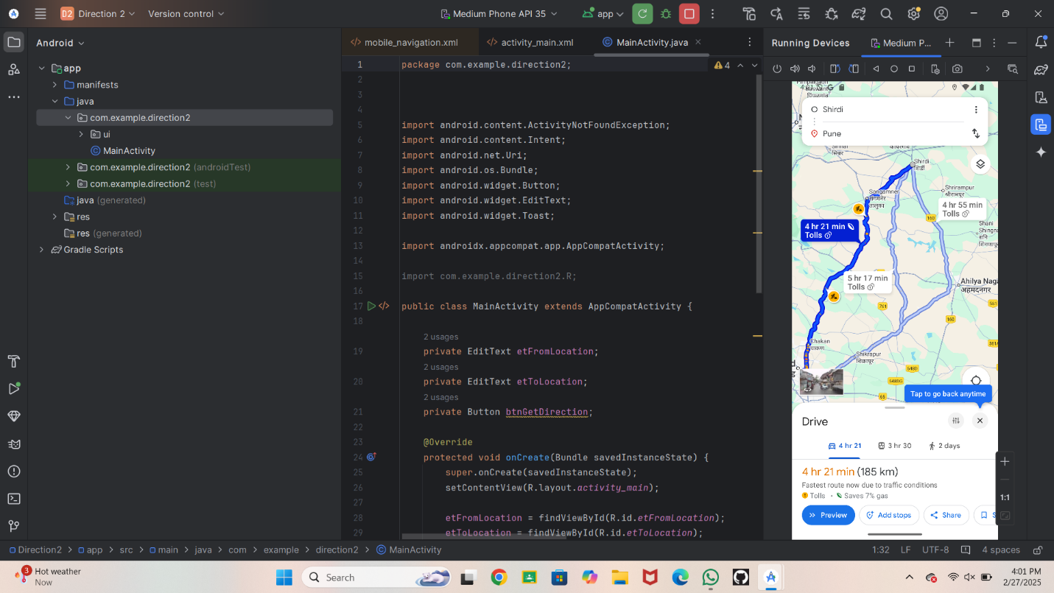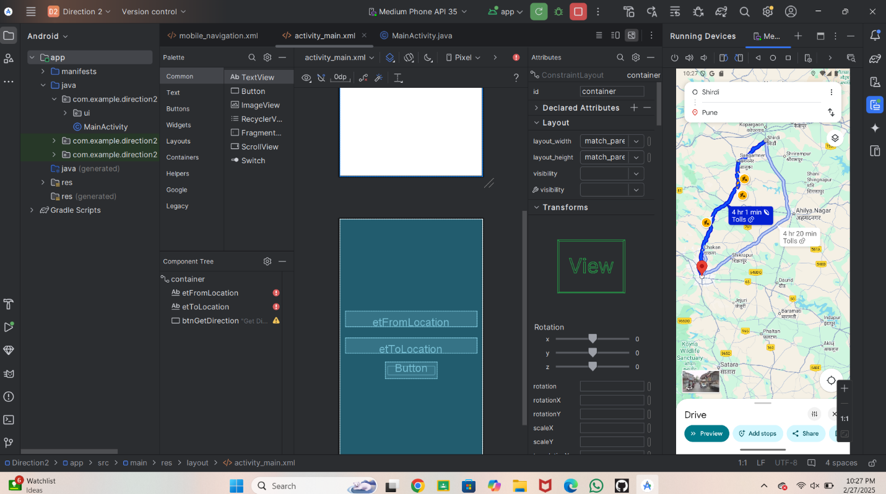

**Conclusion:**

The "Get Direction" feature provides a seamless navigation experience, allowing users to easily find their desired location. This feature enhances user satisfaction, efficiency, and accessibility, making it a valuable addition to any location-based application.